Mini Project - 2

Student Name/ID Number: | Viddy Virstandi Paramanayaka Andanawari Purnama / BDSE04-0322
Unit Number and Title: | ACWD Module 5 – Web Development Foundations
Academic Year: | 2022
Unit Assessor: | Arvinder Kaur
Project Title: | Development of a Registration Form in JSP with Database (Not Struts)
Issue Date: | 01/09/2022
Submission Date: | 08/09/2022
Internal Verifier Name:
Date: | 08/09/2022

Learner declaration
I certify that the work submitted for this assignment is my own and research sources are fully acknowledged.

Student signature: Viddy Virstandi P.A.P Date: 08/09/2022

Purpose of this project
Purpose of this project
To demonstrate your capabilities in the following areas:
- Create a JSP Form
- Save the submitted data to Database
Submission Format
- Screen capture of Database Table
- Screen capture of the Form and Thank you Page
- Screen capture of Database table with data
Project Brief & Guidance
Scenario:

Refer to the Project Scenario for the Module Project
You have been approached by ‘ABC Jobs Pte Ltd’ as a website developer to develop a community portal for Software Developers. The project will be carried over through Module 3, Module 4, Module 5 and Capstone project. For this module the scope is to Design, Develop, Implement & Document Apache Struts Framework Website.
The Scope of the Project is to design a Community Portal Similar to Linkedin.com. Users will be able to register in the portal using the Registration Page. Users of the portal can search for other users using various parameters such as First Name, Last Name, Company Name, City & Country. Users will be able to view the Public Profile of users after searching them. The portal allow users to login, request for forgotten password and Update their profile information
The scope of the project in this modules is for development of Apache Struts Website.
The scope of the project in this modules is to develop the database.

The overview of the project is as below
There are 2 types of users in this Community portal. They are
- Software Programmer
- Administrator

Software Programmer should be able to perform following functions in the portal

- Allow the programmers to register in the portal, show a thank you page & send a registration confirmation email.
- Search & Find Other Programmers after login and view their profile.
- Provide Login Page
- Provide password retrieval functionality.
- Update their Profile after logging in.

Following Functionality is part of Database Design & Will be enhanced as features as required in the Capstone Project, Depending on time availability.

- Send Messages to Each Other on the Portal
- Create Threads & Post Replies to a Thread
- Post Job Opportunities in the Portal

Administrator should be able to perform following functions in the portal
- Administer user data.
- Send bulk email inviting programmers to register on the community portal

The portal consist of the following Key pages (For Reference)
- Community Portal Home Page
- Registration Page
- Registration Confirmation Page
- Update Profile Page
- Search Users Page
- List Search Results
- Public Profile Page
- Registration Confirmation Email
- Login Page
- Forget Password Page
- Design the Forget Password Confirmation Page

Following Functionality is part of Database Design and will not be part of development & Will be enhanced as features are required in the Capstone Project, Depending on time availability.
- Send Messages
- Read Messages
- Post in Message Board
- List Message Board
- Read A Thread
- Post Job Opportunities
- List Job Opportunities & Responses

The scope of this assignment
The scope is to setup a SpringProject, Create all the SpringFormsfor the following functionality
1.Allow the programmers to register in the portal, show a thank you page & send a registration confirmation email.
2.Search & Find Other Programmers after login and view their profile.
3.Provide Login Page4.Provide password retrieval functionality.
5.Update their Profile after logging in.

The site does not need a backend integration (Back end integration will be done in Mini Project 3), but all other display views, java script validations, url mappings etc.

a.Provide screen capture of HTML Pages with Springforms.
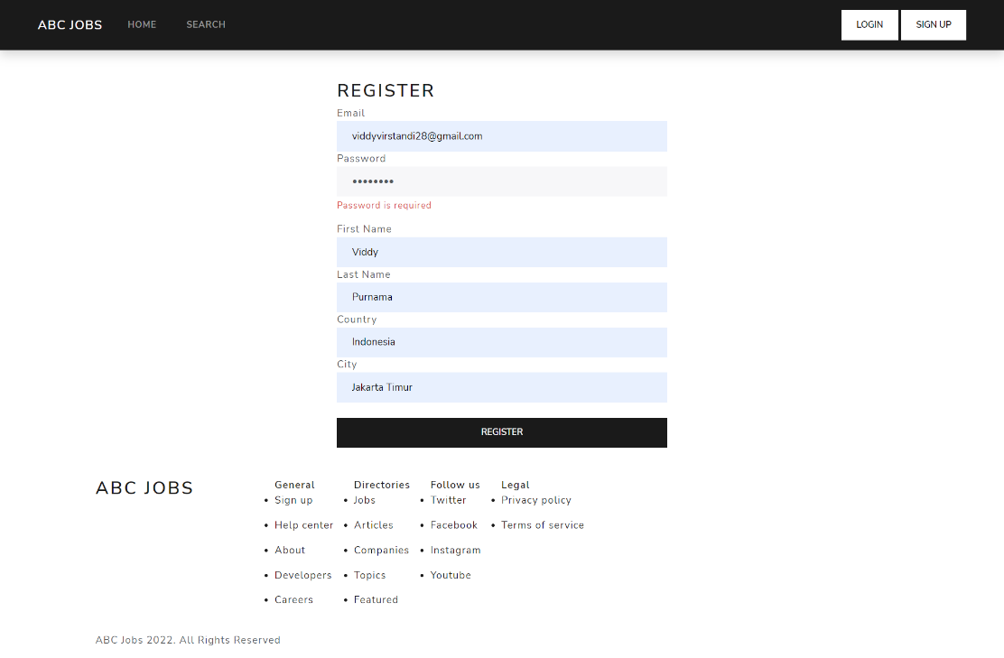

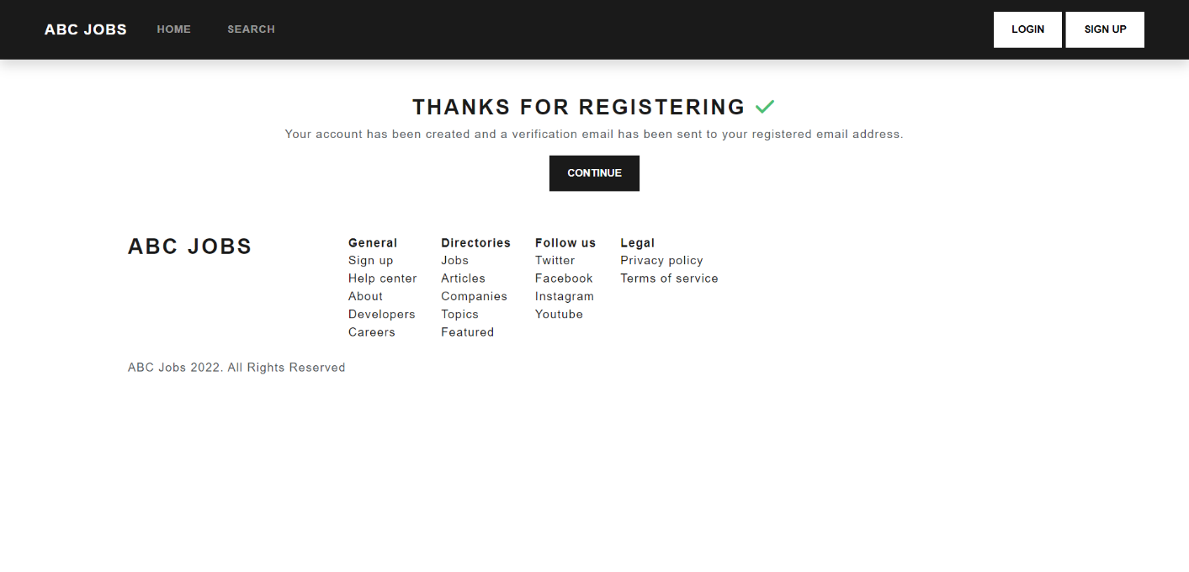

b.Provide sources of Models

